Mouse Keybind Scheme
Razer Basilisk V3, Standard Edition, Wired Gaming Mouse
Product Identification
Manufacturer Part #: RZ01-04000100-R3U1
UPC: 810056143336
Manufacturer: Razer
Core Features: 11 programmable buttons, on-device memory, 4-way scroll wheel

Extra Button Identification
White: Forward => Hypershift button
Red: S. Clutch => Paddle button (use V2, or modify to extend further)
Green: Back button
Blue: Free-scroll clutch, invariant to modifiers, chords, even modalities
Yellow: Helper button
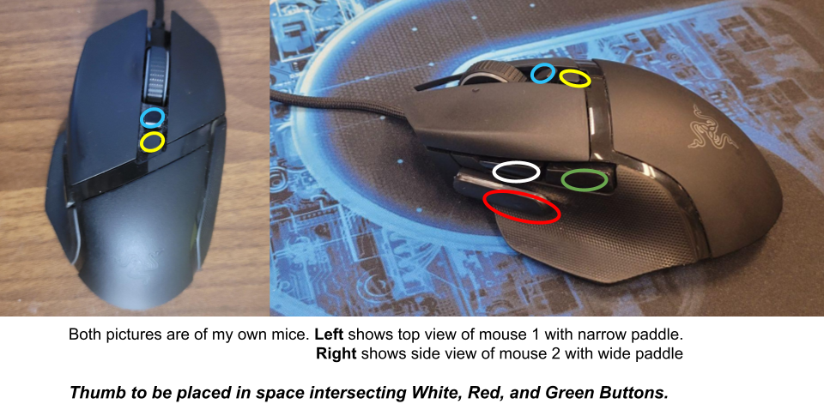

Button Mappings in Razer Synapse:
Recommended to uninstall this software after saving to memory
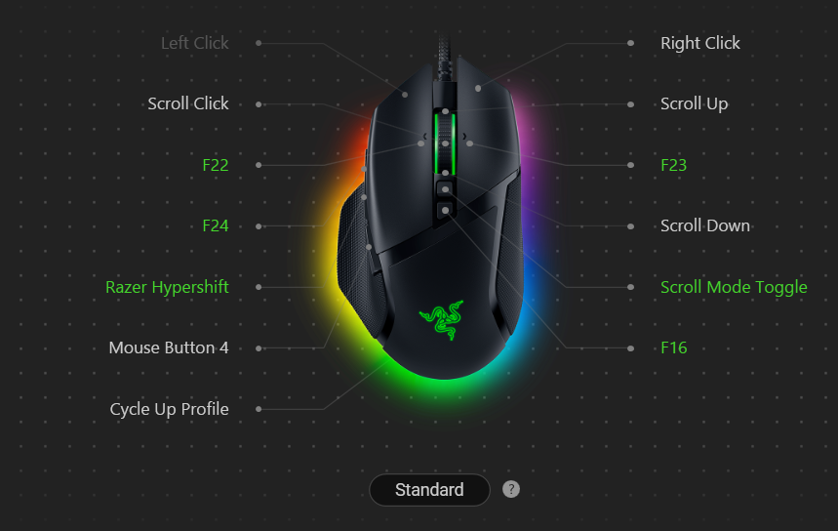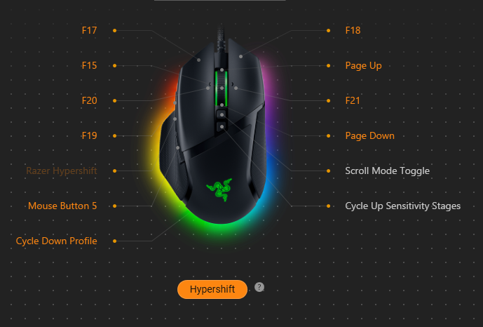

Basic Mode
Activation: no modifiers are pressed
Operations: basic mouse functions, web browsing, window navigation
Lclick – lclick
Rclick – rclick
Scrollup – scrollup
Scrolldown – scrolldown
Scrollleft – ctrl +w (close tab on Chrome and other programs)
Scrollright – ctrl + t (open tab on Chrome and other programs)
MClick – mclick
Back – Go back
Helper – Minimize current active window

Hypershift (better called Web Browsing) Mode
Activation: hypershift is pressed and held
Operations: web browsing
LClick => ctrl + shift + tab (switch to leftward tab, hold to advance fast; increase indent of list in word editor)
RClick => ctrl + tab (switch to rightward tab, hold to advance fast; increase indent of list in word editor)
Scrollup – scrollup, via PgUp press
Scrolldown – scrolldown, via PgDn press
Scrollleft => ctrl + shift + t (reopen closed tabs)
Scrollright => ctrl + r (reloads page)
MClick => Alt + F1 (closes current program, shutdown controls on desktop)
Back – Go forward
Helper => cycles DPI

Back (better called Revision) Mode
Activation: when only the Back is pressed and held
Operations: text and carat manipulation, undo and redo, long-form selection
LClick => alt + lclick (mouse click with modifier key-press, use for duplicating carat in editor)
modifier key-press – alt in VSCode, ctrl in all other cases
RClick => shift + lclick (mouse click with shift, use to select long bodied text)
only when pressed by itself without having done anything else
=> shift toggle (holds down shift button until released, behaves like a modifier)
NOTE: if the back is released before RClick, shift will persist until release
This never naturally happens during use, so it doesn’t matter at all.
Scrollleft => ctrl + z (undo, hold to undo fast)
Scrollright => ctrl + y (redo, hold to rewind fast)
MClick => ctrl + s (save, various software)
Scrollup – custom swap line with the line directly above, VScode only
Use paddle simultaneously to enter BackPaddle mode and move carat up
Hold right click to PLACEHOLDER
Compatible with clicking and dragging to select, and transferable.
Scrolldown – custom swap line with the line directly below, VScode only
Use paddle simultaneously to enter BackPaddle mode and move carat down
Same capacity as above, with ONE NOTABLE EXCEPTION:
Hold right click to DUPLICATE line below (only for Vscode, uses clipboard for other)
Helper => ctrl + e (jump to search in chrome, centre align text in word editor, go to in VScode)

Paddle (better called Editor) Mode
Activation: when only the Paddle is pressed and held
Operations: text and carat manipulation, copy, paste, enter/backspace input
LClick => ctrl + v (paste) only without extraneous input; holding RClick will trigger dual click
RClick => ctrl + c (copy) only when pressed by itself, without having done anything else
=> ctrl + x (cut) double tap for cut
=> gear toggle (for other combinations, holds down shift button OR other modifier until released, behaves like a modifier toggle)
Warning: if the paddle is released before RClick, gear will persist until release
=> dual click (for other combinations) This special toggle is used to determine whether “ctrl” is used during scrolling, cycling between scrolling by words or letters
RClick (hold), proceeded by LClick (click and release) – this enables select left/rightward by letter (removing ctrl from scroll inputs). Lclick can be pressed again to cycle between scrolling by letter or word.
You can also release Rclick afterwards – enables move carat left/right by letter.
Scrollup – ctrl + left (move carat leftward by word; select left in menu, back to previous segment in YouTube; simultaneously hold back to move carat up.
Transition between horizontal and vertical selection as you please.
You can hold shift while doing so to preserve your selection.
For convenience, you are able to hold shift with your left hand to select text, emulating click and drag.
Somewhat compatible with clicking and dragging to select.
Specifically, click and drag a direction to select, then continue selection with scrolling
Hold right click to hold shift without using keyboard – gear toggle
Dual Click to deactivate ctrl and move carat by letter, LClick to cycle on and off
- Ctrl always starts out activated by default whenever Paddle is pressed
- You may move carat or select, by word or by letter. Read instructions above.
Scrolldown – ctrl + right (move carat rightward by word; select right in menu, forward to next segment
in YouTube; simultaneously hold back to move carat down. Same capacity as above.)
Scrollleft => backspace (hold Rclick (gear toggle) to input shift + home; select left entire line)
In File Explorer, HOLD Rclick, and you grab the MOST RECENT file from the downloads folder or the screenshots folder and move it to the currently active directory window~!
Scrollright => delete (hold Rclick (gear toggle) to input shift + end; select right entire line)
MClick => enter (hold Rclick (gear toggle) to input shift + enter; new line without break)
In File Explorer, you can quickly rename files or folders; Mclick => (F2), Enter
Hold Rclick to create a new folder (ctrl + shift + n)
Helper => ctrl + h (open history in chrome, find and replace in editors)
Dual Click to activate Placeholder

HyperPaddle (better called Multimedia) Mode
Activation: press the hypershift, followed by the paddle, both held down; a downward motion
Operations: assorted functions, media and window management
RELEASE => Window Arranger (WA) Activation Toggle, press again to secure
LClick => shift + win + s (take screenshot, without snipping tool popup)
RClick => win + ctrl + c (take screenshot via Snipping Tool, pop up editing window)
From here, available functions include editing and AI text extraction
Scrollup – ctrl + scrollup (zoom in) if WA toggled, then (Window Maximize)
Scrolldown – ctrl + scrolldown (zoom out) if WA toggled, then (Window Minimize)
Scrollleft => ctrl + win + left (Window arrange on left monitor), WA Activation
Scrollright => ctrl + win + right (Window arrange on right monitor), WA Activation

BackPaddle (better called Secondary Editor) Mode
Activation: press the paddle, followed by the back, both held down; a down-up motion
Activation (alt): press back, followed by paddle, both held down; a downward motion
Operations: text and carat manipulation, a few select web browsing operations
LClick => win + v (clipboard history)
paste history special controls:
- Hold the Backpaddle and scroll (up/down) to select history entry
- Hold the Backpaddle and hit Mclick (Enter) to paste
RClick => shift toggle holds down shift button until released, behaves like a modifier
input LClick (as if dual clicking) to activate Windows Advanced Paste (shift + win + v) menu. Includes pasting as plaintext, txt files, or AI edits.
NOTE: if the back is released before RClick, shift will persist until release
This never naturally happens during use, so it doesn’t matter at all.
Scrollup – up (scrollup by 1 line, move carat up in editors, use paddle to move or select carat left by word)
Hold shift and transition between horizontal and vertical selection as you please.
Hold right click to hold shift without using keyboard.
Compatible with clicking and dragging to select, and transferable.)
Scrolldown – down (scrolldown by 1 line, move carat down in editors, use paddle to move or select carat right by word) Same as above.
Scrollleft => (In browsers) Ctrl + 9 Select rightmost tab
Scrollright => (In browsers) Ctrl + 1 Select leftmost tab
Mclick => Placeholder

HyperBack (better called Data Entry) Mode
Activation: press the hypershift, then back button, both held down
Operations: spreadsheet cell operations, code editor functions, web browsing
LClick => reposition current tab leftward, hold to swap fast
RClick => reposition current tab rightward, hold to swap fast
Scrollup – shift + scrollup (Horizontal Left Scroll)
Scrolldown – shift + scrolldown (Horizontal Right Scroll)

HyperBackPaddle (better called Coding) Mode
Activation: press every modifier button simultaneously, in the chord sequence H -> B -> P
Operations: coding, complex environment-specific commands
Scrollup – alt + scrollup (jump to previous function header)
Scrolldown – alt + scrolldown (jump to next function header)
Mclick => open VScode in this current folder in Windows File explorer

HyperPaddleBack (better called Typing Input) Mode
Activation: press every modifier button simultaneously, in the chord sequence H -> P -> B
Operations: Typing assistance, release chord to enter Extended TriCanth typing Mode
RELEASE => Extended TriCanth Typing

